**SAD TUTORIAL**

**WEEK 06 – SEQUENCE DIAGRAM**

*\* Write all your answers in a word document and submit your work to the submission box.*

**Review question:**

1. What does a sequence diagram show you?

* A sequence diagram shows different parts of a system work in a ‘sequence’ to get something done.

1. Name the four numbered elements in this diagram:

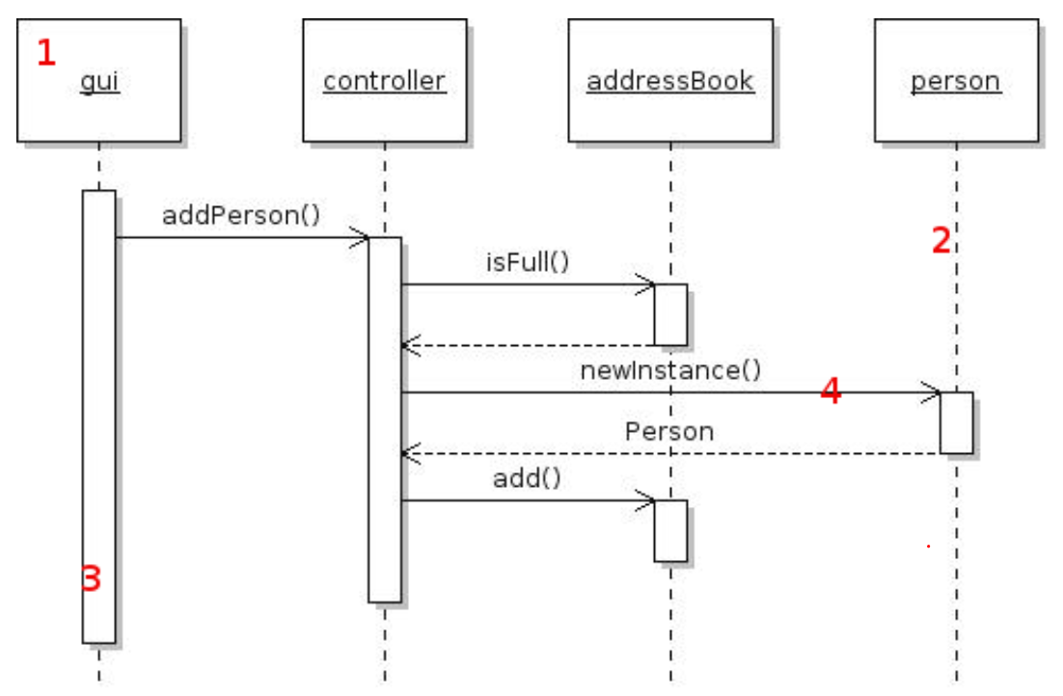

1. Object
2. Object lifeline
3. Activation bar
4. Asynchronous message

**EXERCISES**

1. **Draw a sequence diagram for the situation when one Student Login to Fit Portal**
   1. List step by step to implement the function in your own words

Step 1: Go to Fit Portal and Click on Login button

Step 2: Enter Username and password 🡪 Login

Step 3: Controller validate user

Step 4: If the result is false, alert “Invalid login, please try again”

Else, login successfully, return to Home Page or Dashboards in Fit portal

* 1. Draw the diagram
     1. Make sure your diagram clearly shows which objects are in this process
     2. Objects that you must include are
     + Student
     + Login Pages
     + Home Pages
     + Account Controller
     + Student Entity
     1. You can include other objects if you need them to make your diagram clearly

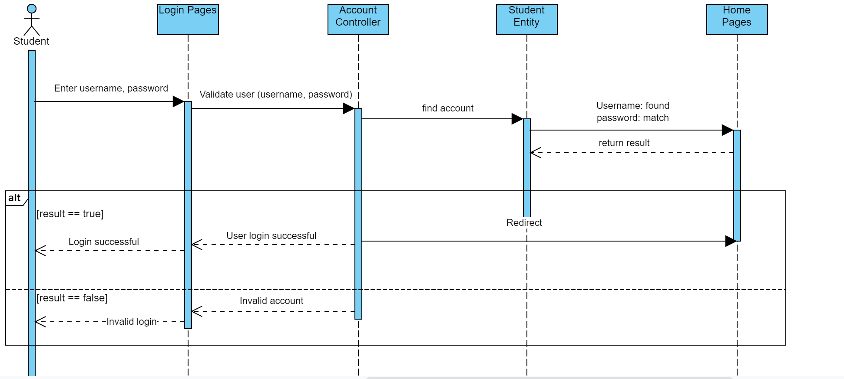

1. **Draw a sequence diagram for creating new account at https://chieuphimquocgia.com.vn/register**
   1. List step by step to implement the function in your own words

Step 1: Input personal information (name, telephone, identity card number, password, …) to sign up

Step 2: Check whether user’s input is true or not

Step 3: Register Pages automatically allow your privilege to web page by sending data to email to activate account

Step 4: If data is confirmed in right email, account created

Else, fail to create new account

* 1. Draw the diagram
     1. Make sure your diagram clearly shows which objects are created when customer register for a new account
     2. The order in which objects are created or invoked is important.
     3. Objects that you must include are
     + Customer
     + Register Pages,
     + Home Pages,
     + Customer Controller
     + Customer Entity
     1. You can include other objects if you need them to make your diagram clearly

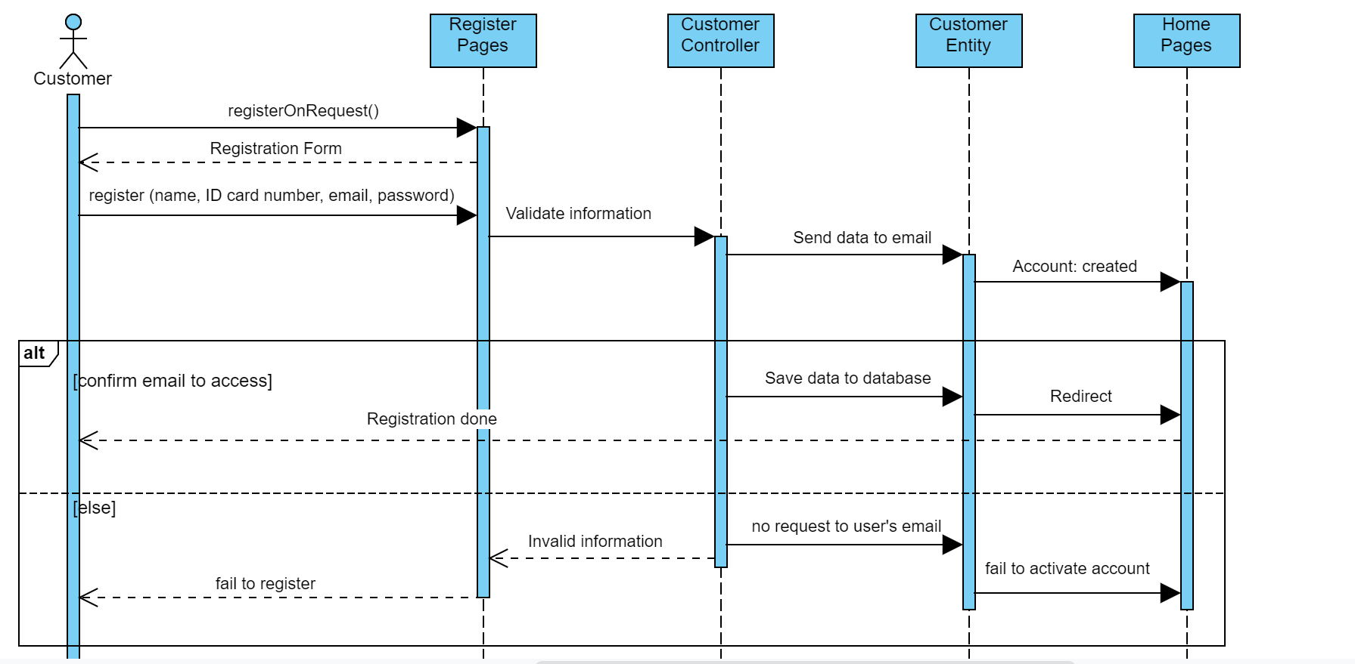

1. **Draw a sequence diagram for forgot password process**
   1. Make sure your diagram clearly shows which objects are in this process
   2. You can include other objects

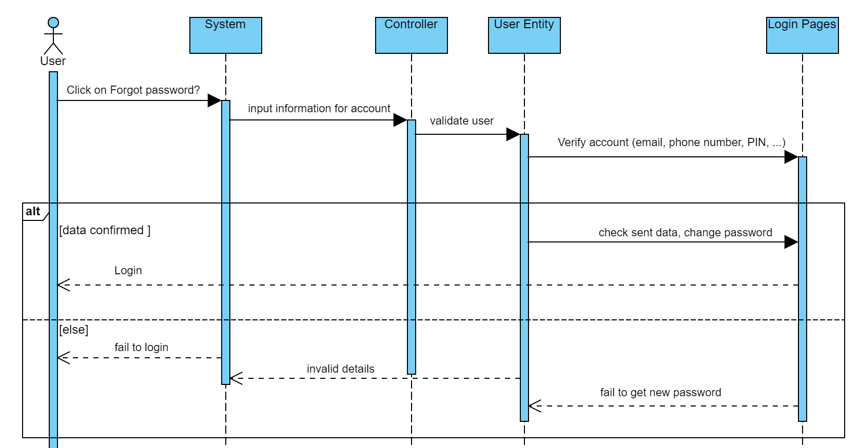

1. **Pick up at least 3 use cases in this use case diagram bellow to draw sequence diagram**

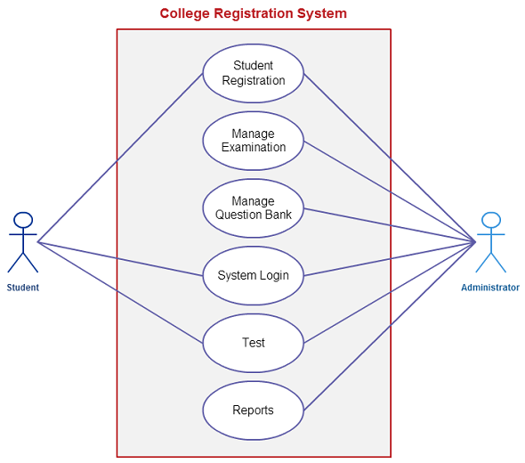

**Student Registration**

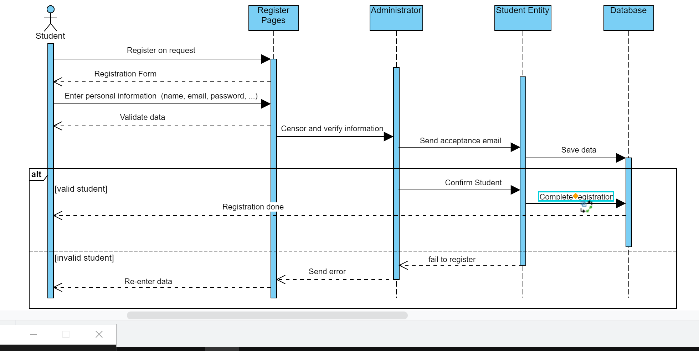

**System Login**



**Tests**

